Practical No 8

Aim:- Using Sysinternals tools for Process Monitoring

Windows Sysinternals tools are utilities to manage, diagnose, troubleshoot, and monitor a Microsoft Windows environment.

The following are the categories of Sysinternals Tools:

* 1. File and Disk Utilities
  2. Process Utilities

## Monitor Live Processes : (Tool: ProcMon) To Do:

1. Filter (Process Name or PID or Architecture, etc)
2. Process Tree
3. Process Activity Summary Count Occurrences

Output 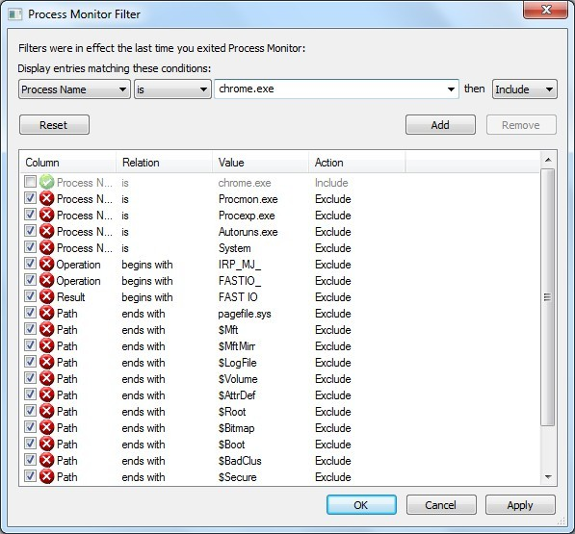

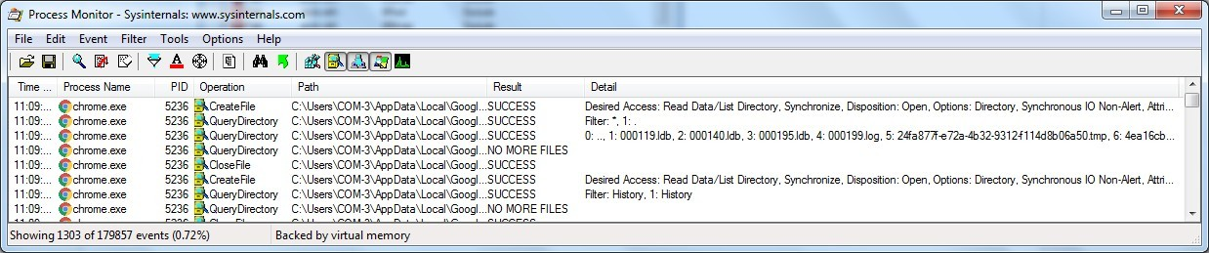

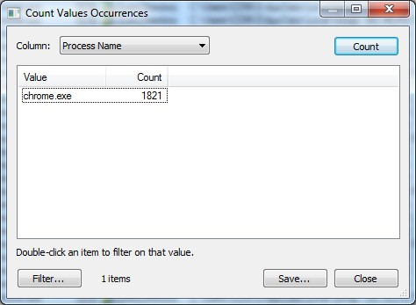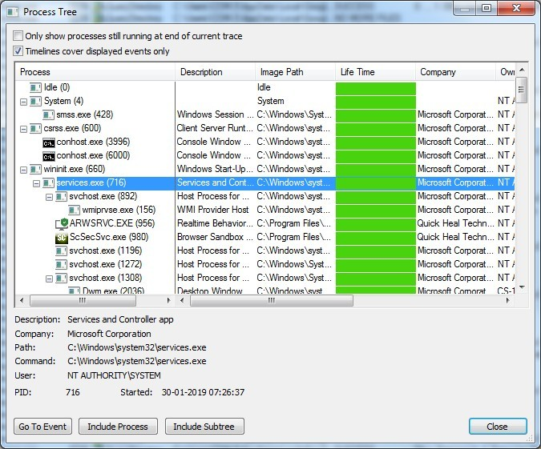

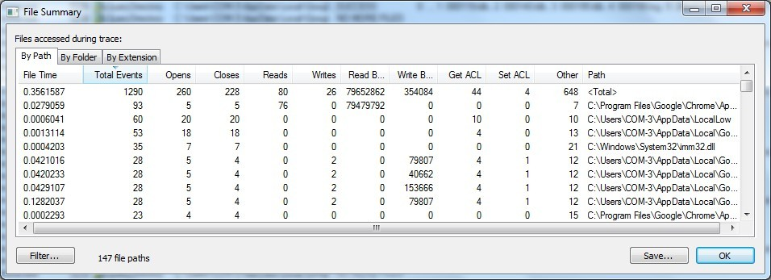

1. **Capture RAM (Tool: RAMCapture)**
   1. Click Capture
   2. Creates a .mem file of the system memory (RAM) utilized.

Output

